**Open Lab Project 01**

In this project we will build a PHP application that accepts a form submission to test our knowledge. Be sure to document all of your code to indicate your understanding.

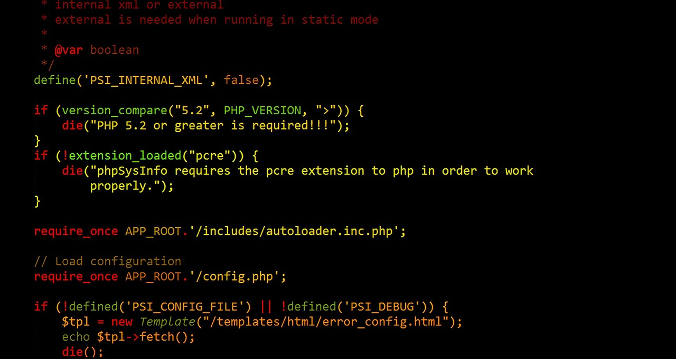 

In this project, you will use a Web form that you previously built to experiment with a submission to a PHP file. The object will be to access various superglobals in the PHP file and to output their keys and values to the Web page. All output should be nicely formatted. The work product should look like a professional Web page, and this will be reflected in your grade.

1. Create a new sandbox directory for this project, as well as a ***server*** folder to test your work. Copy all of the files from ***Exercise 01_06_01*** into your folders, with the exception of ***results.html***.
2. Open the file ***snoot.html***. Find the ***<form>*** element and change its attributes to use a PHP form handler file. The ***action*** attribute should be set to “***results.php***”. Create a ***method*** attribute with the value “***post***”.
3. Create a new file called ***results.php***. Scaffold a basic HTML code layout into it. Set the <title> to Form ***Results***. Make sure to have the ***modernizr*** <script> linked in.
4. Implement the HTML and the code to build a nice web page to display superglobal output. First display the results of the ***$_SERVER*** Superglobal. These results should be nicely formatted and display the name of the superglobal, along with the key and the value of each of its elements. This should be a professional-looking display.
5. Implement the code to display the form results from the ***$_POST*** Superglobal. These results should be nicely formatted and display the name of the superglobal, along with the key and the value of each of its elements. This should be a professional-looking display.
6. Zip up all of your files and turn them in to Google Classroom ***Open Lab***. Your files must be turned in ***as is*** at the end of the class period.